the Sakila schema, which can be found in following link (to be installed in your local system)

http://dev.mysql.com/doc/index-other.html("sakila database")

http://dev.mysql.com/doc/sakila/en/sakila.html(for full documentation)

Requirements

For each question, you are required to provide the following:

- The SQL query you used

- The answers

- Any assumptions you made

5. Problem Statement

1. Return the categories (names) of the longest film. NOTE that there may be several "longest"

films (i.e. with the same length), so you might need to return more than one category. Return

the duration as well.

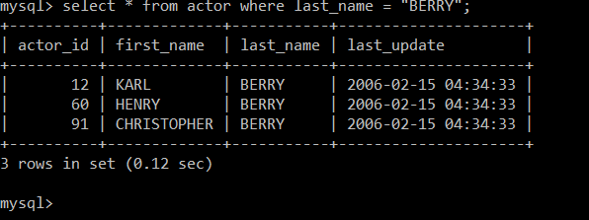

2. Find the movies whose total number of actors is above the average. Return the movie names

and its number of actors ordered by the title. IMPORTANT NOTE: this query should return many

movies. Please write in your submission only the first TOP-10 results.

